circuit switching vs packet switching
TDM/FDM: Time/Frequency-Division Multiplexing
d_nodal = d_processing + d_queueing + d_transmission + d_propagation
application | FTP, HTTP, SSH, DNS
transport | TCP, UDP
network | IPv4, IPv6
link | Ethernet, 802.11, DSL, ISDN
physical | Ethernet, 802.11, DSL, ISDN

nonpersistent HTTP: at most 1 object per TCP connection (2RTT + t_transm)
HTTP methods: GET, HEAD (GET without body), POST, PUT, DELETE, ...

FTP:
control connection port 21, data connection port 20
control information sent out-of-band
HTTP: control info sent in-band
FTP: data connections are non-persistent (1 per file), initiated by server
control connection remains open througout session
server must maintain state info

DNS records: | (Name, | Value, | Type, | TTL)
 | hostname | IP | A
 | domain | hostn. of authorat. DNS server | NS
 | hostname | canonical name | CNAME
 | domain | name of mail server | MX

Demultiplexing:
UDP socket identified by: (destIP, destPort)
TCP socket identified by: (sourceIP, sourcePort, destIP, destPort)

checksum: sum of 16 bit words, wraping around overflow, than take 1's complement (bitwise not), check @ rec: checksum+data = 111...1111

Go-back-N:
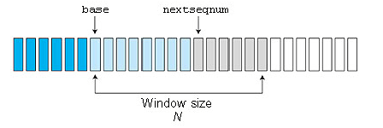
cumulative ack for last in-order received
receiver discards packets other than expected seqnum

Selective Repeat:
individual ACKs, send_base, nextseqnum, window size, timeouts

UDP segment structure:
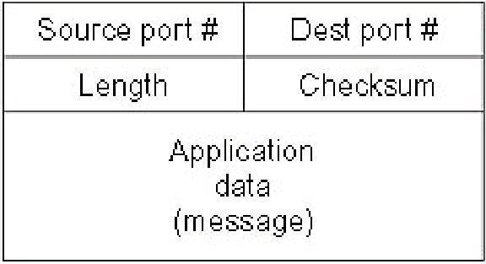
TCP segment structure:
Source port |  |  |  |  |  |  |  |  |  |  | Destination port
Sequence number
Acknowledgment number
header  length | Re-  served | N  S | C  W  R | E  C  E | U  R  G | A  C  K | P  S  H | R  S  T | S  Y  N | F  I  N | Window Size
Checksum |  |  |  |  |  |  |  |  |  |  | Urgent pointer
Options
Data

TCP
1 connection for Process A <--> Process B (full duplex service)
MSS: max. segment size Headers + MSS ≤ MTU
MTU: max. transmission unit (1460, 536, 512 bytes)
seq num = index of first byte
ACK contains seq-no of last fully received + 1, i.e. next you want
initial seq num chosen randomly (avoid confusion with old segments from already closed connections)
1 segment can contain data + piggybacke d ACK

P2P: DHTs store (key,value) pairs. circular DHT with shortcuts. coping with peer churn: each peer knows several successors.
BitTorrent: key=torrent identifier, value=IPs of peers
updating:
EstimatedRTT = (1-α)*EstimatedRTT + α*SampleRTT
DevRTT = (1-β)*DevRTT + β*abs(SampleRTT-EstimatedRTT)
recommendations: α =0.125, β=0.25
TimeoutInterval = EstimatedRTT + 4*DevRTT
but after timout: TimeoutInt = 2*TimeoutInt (don't make congestion worse)
usually acking two in-order segments with 1 ACK
triple duplicate ACK -> retransmit
three-way handshake
RST flag bit = „I don't have a socket for that segment“
LastByteSent – LastByteAcked <= min{cwnd, rwnd}

TCP Tahoe (old): cwnd := 1 after every loss
TCP Reno (new): triple dup. ACK: ssthresh := cwnd/2, cwnd := ssthresh + 3
slow start: exponential growth of cwnd
congestion avoidance: linearly
fast retransmit: resend on triple dup. ACK
fast recovery: after triple dup. ACK, do congestion av. instead of slow start

congestion control: in network
flow control make sure sender doesn't overwhelm receiver

terminal commands:
telnet compnet.epfl.ch 80
nslookup adelaide.edu.au
nslookup 192.43.228.130
nslookup -type=cname 192.43.228.130
nslookup -type=NS epfl.ch a.root-servers.net
nslookup 4.3.2.1.pbl.spamhaus.org
traceroute meteoschweiz.ch
ifconfig -a
ping compnet.epfl.ch
netstat [--tcp|-t] [--udp|-u]
ssh icin2pc34

TCPClient
Socket clientSocket = new Socket("hostname", 6789)
new DataOutputStream(clientSocket.getOutputStream())
new InputStreamReader(clientSocket.getInputStream()))
clientSocket.close()

TCPServer
ServerSocket welcomeSocket = new ServerSocket(6789)
while(true) {
Socket connSocket = welcomeSocket.accept()
new InputStreamReader(connSocket.getInputStream()))
new DataOutputStream(connSocket.getOutputStream())
}

UDPClient
DatagramSocket clientSocket = new DatagramSocket();
InetAddress ipAddress = InetAddress.getByName("hostname");
byte[] sendData = new byte[1024];
byte[] receiveData = new byte[1024];
DatagramPacket sendPacket = new DatagramPacket(
sendData, sendData.length, ipAddress, 9876);
clientSocket.send(sendPacket);
DatagramPacket receivePacket =
new DatagramPacket(receiveData, receiveData.length);
clientSocket.receive(receivePacket);
clientSocket.close();

UDPServer
DatagramSocket serverSocket = new DatagramSocket(9876);
byte[] receiveData = new byte[1024];
byte[] sendData = new byte[1024];
while(true) {
DatagramPacket receivePacket = new DatagramPacket(
receiveData, receiveData.length);
serverSocket.receive(receivePacket);
InetAddress IPAddress = receivePacket.getAddress();
int port = receivePacket.getPort();
DatagramPacket sendPacket = new DatagramPacket(
sendData, sendData.length, IPAddress, port);
serverSocket.send(sendPacket);
}

delay D to distrubute file of size F to N hosts:
D_client-server = max { N F u_server, F / d_min }
D_P2P = max { F / u_server, F / d_min, N F / (u_server + sum u_i) }
Chapter 4: Network Layer

1) forwarding: move packets from router’s input to appropriate router output
2) routing: determine route taken by packets from source to dest.
routing algorithm: local forwarding table: header value => output link
3) connection setup in some network architectures: before datagrams flow, two end hosts and intervening routers establish virtual connection

network vs transport layer connection service:
network: between two hosts, transport: between two processes

Network Layer Service Models
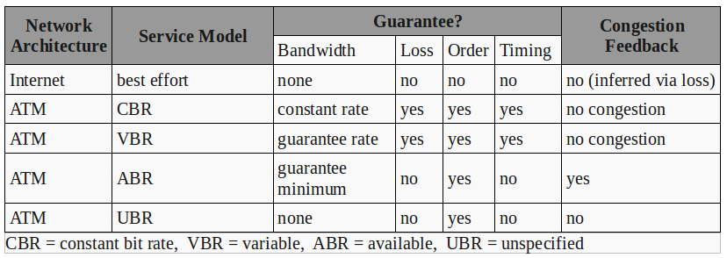
network layer connection VC network
vs connection-less service datagram network
host-to-host service, no choice: network provides one or the other

Virtual circuits : “source-to-dest path behaves much like telephone circuit”
call setup, teardown for each call , every router on source-dest path maintains “state” for each passing connection
link, router resources (bandwidth, buffers) may be allocated to VC

A VC consists of:
1. path from source to destination
2. VC numbers, one number for each link along path
3. entries in forwarding tables in routers along path
packet belonging to VC carries VC number (rather than dest address)
VC number can be changed on each link (new VC number comes from forwarding table )
Forwarding table in router:
| Incoming interface | Incoming VC # | Outgoing interface | Outgoing VC # |

Datagram networks:
packets forwarded using destination host address
forwarding table: Destination Address Range => Link Interface

Three types of switching fabrics:
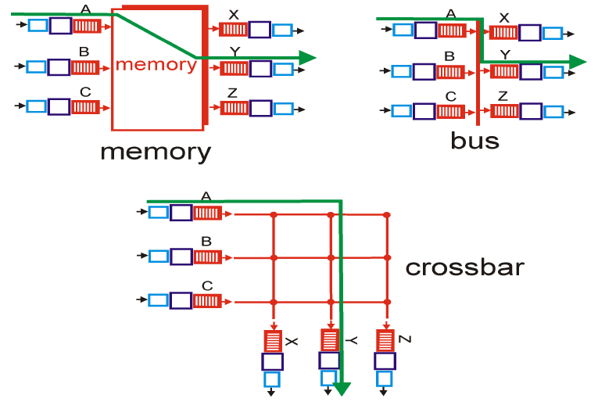
scheduling discipline: chooses among queued datagrams for transmission
how much buffering? RTT*C or RTT*C/sqrt(N)
C: link capacity, N: flows
input buffer overflow, output buffer overflow

Network layer =
IP protocol  • addressing conventions  • datagram format  • packet handling conventions | Routing protocols  • path selection  • RIP, OSPF, BGP | forwarding table | ICMP protocol  • error reporting  • router “signaling”

IPv4 packet:
0–3 | 4–7 | 8–13 | 14-15 | 16–18 | 19–31
Version | Header Length | type of service |  | Total Length
Identification |  |  |  | Flags | Fragment Offset
Time to Live |  | Protocol |  | Header Checksum
Source IP Address
Destination IP Address
Options ( if Header Length > 5 )
Data

=> 20 bytes of IP overhead, + 20 bytes of TCP overhead
IP Fragmentation & Reassembly
network links have MTU – largest possible link-level frame
large IP datagram divided (“fragmented”) within net, “reassembled” only at final destination
IP header bits used to identify/order related fragments
Flags: 3 bits: 0, DF (don't fragment), MF (more fragments)
fragmented packets: all fragments except the last have the MF flag set
Fragment Offset : measured in units of eight-byte blocks, relative to the beginning of the original unfragmented IP datagram

IP Addressing: routers typically have multiple interfaces, host ty. has one

Subnets
IP address = subnet part (high order bits) + host part (low order bits)
device interfaces with same subnet part can physically reach each other without intervening router

CIDR: Classless InterDomain Routing
a.b.c.d/x x = # bits in subnet portion of address
Example:
ISP's block 200.23.16.0/20
Organization 0 200.23.16.0/23
Organization 1 200.23.18.0/23
...
Organization 7 200.23.30.0/23

DHCP: Dynamic Host Configuration Protocol: dynamically get IP address from a server
Example scenario:
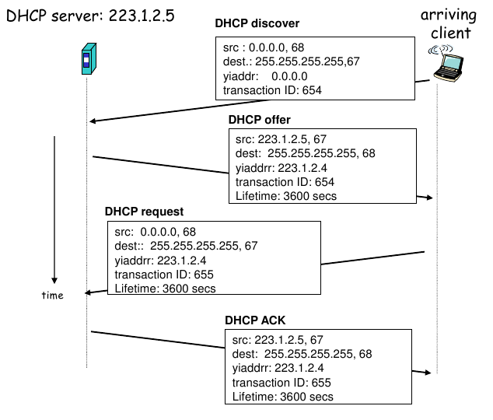
NAT: Network Address Translation
All datagrams leaving local network have same single source NAT IP address, but different source port numbers
NAT router: (source IP address, port #) <==> (NAT IP address, new port #)

ICMP: Internet Control Message Protocol
used by hosts & routers to communicate network-level information
– error reporting: unreachable host, network, port, protocol
– echo request/reply (used by ping)
ICMP message: type, code plus first 8 bytes of IP datagram causing error

Traceroute and ICMP:
source sends UPD segments with TTL=1, 2, ...,
router discards datagram and sends to source an ICMP message

IPv6 Header:
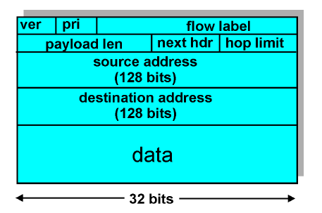
changes from IPv4:
Checksum: removed entirely to reduce processing time at each hop
Options: allowed, but outside of header, indicated by “Next Header” field

Routing algorithms
A) Link state routing: Dijkstra
B) Distance Vector routing
Bellman-Ford Equation (dynamic programming)
Define d_x(y) := cost of least-cost path from x to y
Then d_x(y) = min_v {c(x,v) + d_v(y) } v all neighbours of x
D_x(y) = estimate of least cost from x to y
Node x knows cost to each neighbor v: c(x,v)
Node x maintains distance vector D_x = [Dx(y): y є N ]
Node x also maintains its neighbors’ distance vectors:
for each neighbor v, x maintains D_v = [D_v(y): y є N ]
When a node x receives new DV estimate from neighbor, it updates its own
wait (for cost change or msg from neighbor) => recompute => notify => ...
change => DV does not change: possible => router does not notify neighbors

routing loops may occur (until forwarding tables are all updated)
poisoned reverse: if z=>y=>x then z tells x that D_z(x) = ∞
does not solve problem if loop of >= 3 nodes
good news travels fast bad news travels slow / count-to-infinity problem

Hierarchical routing
Internet = network of networks
routers in same AS (autonomous system) run same routing protocol
Gateway router: Direct link to router in another AS

Intra-AS Routing (aka Interior Gateway Protocols IGP)
RIP: Routing Inf. Pr. (DV, distance = # of hops (max = 15 hops))
exchanging distance vectors (every 30s) = advertisement
180s no advertisement: neighbor considered dead
poisoned reverse used to prevent ping-pong loops (∞ = 16)
RIP routing tables managed by app-level process route-d (daemon)
OSPF: Open Shortest Path First
Link-state/Dijkstra. link state broadcast, each node complete graph
advertisements in OSPF messages directly over IP (not TCP or UDP)
„advanced“: security, multipaths, multiple cost metrics, hierarchical

Inter-AS routing
BGP (Border Gateway Protocol): the de facto standard
exchange routing info over semi-permanent TCP connections: BGP sessions
iBGP, eBGP (internal/external)
router may learn about more than 1 route to some prefix. Router must select route (import/routing policy)
advertised route = prefix + attributes. attributes =
- AS-PATH: list of AS numbers
- NEXT-HOP: IP of router-interface that begins AS-PATH (i.e. „last added“)

Broadcast Routing
flooding: when node receives brdcst pckt, sends copy to all neighbors
avoid „storm“/cycles:
- Node keeps track of pckt ids already brdcsted
- reverse path forwarding (RPF): only forward pckt if it arrived on shortest path between node and source
- spanning tree

Multicast
Internet Group Management Protocol (IGMP)
Has three message types: membership_report, membership_query, and leave_group
find a tree (or trees) connecting routers having local mcast group members

Chapter 5: Link Layer

layer 5 app ?
layer 4 transport segment
layer 3 network datagram
layer 2 link frame
layer 1 physical ?

each link protocol provides different services: e.g., may or may not provide rdt over link
header + datagram + trailer = frame
header contains MAC address
error correcting: usually not on fiber/twisted pair (because low-error), but on wireless (high error rate)
link layer implemented in network interface card (NIC), combination of hardware, software, firmware
2 types of “links”: 1) point-to-point 2) broadcast (shared wire or medium)

MAC Protocols: 3 types
- Channel Partitioning: divide channel into smaller “pieces” (time slots, frequency, code), allocate piece to node for exclusive use
  - TDMA: time division multiple access
  - FDMA: frequency division multiple access
- Random Access: channel not divided, allow collisions, “recover” from collisions
  - Slotted ALOHA: if collision: node retransmits frame in each subsequent slot with prob. p until success
    - max efficiency = 1/e = 0.37
  - Pure (unslotted) ALOHA:
    - max efficiency = 1/(2e) = 0.18
  - CSMA (Carrier Sense Mu. Acc.): listen before transmit 802.11
    - If channel sensed idle: transmit entire frame
    - collisions can still occur (propagation delay)
  - CSMA/CD (Collision Detection) Ethernet
    - colliding transmissions detected quickly & aborted, wastage ↓
    - collision detection: easy in wired lan, difficult in wireless
- “Taking turns”: nodes take turns, but nodes with more to send can take longer turns
  - polling protocol (eg Bluetooth): master node
  - token-passing protocol: control token passed from 1 node to next

unique 48 bit MAC address (for most LANs) burned in NIC ROM (also sometimes software settable), Broadcast address = FF-FF-FF-FF-FF-FF
MAC address allocation administered by IEEE, manufacturer buys portion of MAC address space

ARP: Address Resolution Protocol
ARP table: < IP address; MAC address; TTL>
A wants to send datagram to B, and B’s MAC address not in A’s ARP table: A broadcasts ARP query packet, containing B's IP address

Ethernet: today: star topology: active switch in center
Ethernet frame structure:
- Preamble: 7 bytes with pattern 10101010 followed by one byte with pattern 10101011 (synchronize clock rates)
- Dest. Address
- Source Address
- Type indicates higher layer protocol (mostly IP but others possible, e.g., Novell IPX, AppleTalk)
- Data
- CRC CRC: checked at receiver, if error is detected, frame is dropped

Ethernet: unreliable, connection-less
Ethernet’s MAC protocol: unslotted CSMA/CD
after collision: abort, then exponential backoff: after m-th collision, NIC chooses K at random from {0,1,2,…,2^(m-1)}, waits K·512 bit times, send if sensed idle
Jam Signal: make sure all other transmitters are aware of collision; 48 bits
efficiency: 1 / (1 + 5*t_prop/t_trans)
many different Ethernet standards
Manchester encoding:
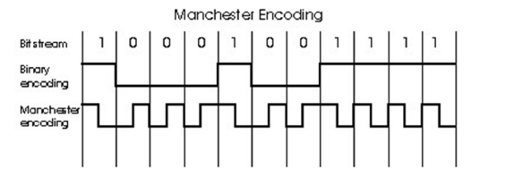
no need for global, synchronized clock

Chapter 7: Multimedia Networking

best effort / differential QoS (classes) / guaranteed QoS

loss recovery schemes:
- forward error correction (FEC):
  - packet #N+1 is xor of others
  - or packet #i contains lower-quality version of packet #i-1
- receiver-based repair (repetition or interpolation)
- interleaving

RTSP (real-time streaming protocol) uses RTP or another protocol
out-of-band protocol for controlling pause/resume/ff/rw...

RTP (real-time transport protocol)
- no QoS mechanism

RTPC (RTP Controtl Protocol)
- different port than RTP, sends statistics about RTP traffic

SIP (session initiation protocol)

Chapter 8: Network Security

stream cipher/block cipher

Cipher block: if input block repeated, will produce same cipher text
Cipher Block Chaining: XOR i-th input block, m(i), with previous block of cipher text, c(i-1) before encrypting
initialization vector = IV = c(0), transmitted to receiver in clear, different in each session
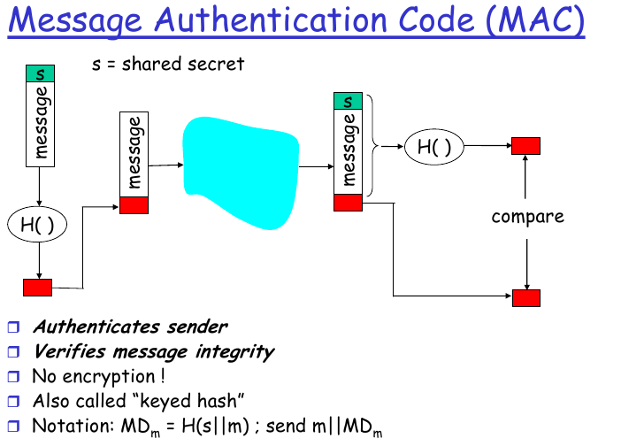
Playback attack: ~ avoided by use of a nonce: use-only-once-word + MAC
Digital signature = signed message digest

Certification Authorities (CA)
When Alice wants Bob’s public key:
- Gets Bob’s certificate (Bob or elsewhere)
- Apply CA’s public key to Bob’s certificate, get Bob’s public key

SSL: between app layer and transport layer

